Progress Report for January 2022
Figure 3. Variation of the porosity within the same (6CP) specimen.

Executive Summary for Digital and Robotic Research Activities

Vison Based Robotic Manufacturing
During January, the updates for this project fall within three main work packages. The first of which is the upgrading of the deburring end-effector, involving modifications to the CAD designs, with the final selection of the requisite equipment. The second work package centers on the counter-sink inspection task, where we have tested an initial prototype for 3D scanning using the UR10 manipulator and a 2D laser profiler. Initial results yielded a poor scanning performance, due to the slow and inaccurate position readings of the robot. To address this issue, we have fabricated a new end-effector with linear actuation and micro-stepping capabilities to provide better position feedback during the scanning phase. The new end-effector will be tested in February. The final work package focuses on developing our novel visuotactile sensor, where attention focuses on improving the fabrication process of the sensor, as well as conducting tensile tests to generate data for inputting into a finite element analysis that will be used to determine the best sensor material and geometry.

Exoskeleton Project
Initial modeling and control design involving simple sensing systems is being developed and this will be deployed in the first prototype of the knee exoskeleton. Subsequently, a full control system approach will be carried out, involving multiple steps being tested in the exoskeleton prototypes. The selection of all of the internal parts, such as the gears and springs that are going to be used in the variable stiffness actuator has been made, based on a kinetic and kinematic analysis of the system. Furthermore, we have introduced a new VSA design using these internal parts, with the aim of producing a more compact size that is compatible with our application, whilst offering the required stiffness and torque values. Once finalized, the design will be sent to the workshop to start the fabrication process. The full integration of the second prototype of the knee exoskeleton with the VSA will be undertaken following receipt of the Maxon motors with a harmonic gear drive. Finally, we have started establishing connections with the medical field in order to initiate the IRB approval process.

A vision-based approach for robotic manufacturing
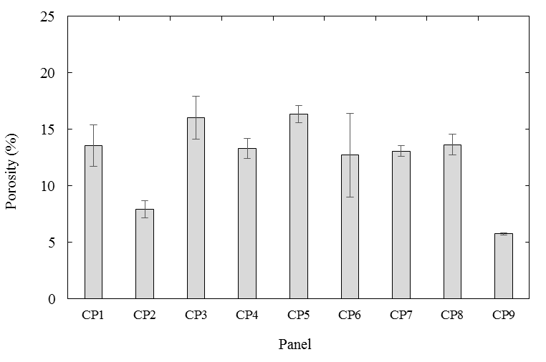
Abdulla Ayyad, Laith Abu-Assi and Dr. Yahya Zweiri
(b)

Project Objectives:
- The development of a STRATA R&D MMO-500 robot to the qualification requirements.
- The development of the robotic deburring end-effector to the industrial specifications of STRATA.
- The development of a robotic painting end-effector for the inner-surface of drilled holes.
- The development of a robotic riveting end-effector.
- The development of a counter-sink inspection capability for the robotic machining platform.
- The research on dynamic vision optical sensing, as per our patent application 2020-034.
- The research on vision-based navigation to supplement the LiDAR system currently in use.
- The research on the integration of dynamic vision and light coding technology for faster surface inspection.
- The training of national Khalifa University students on robotic manufacturing technologies, including the mathematical fundamentals, robotic perception, mechanical design and the operation of robots in the industry.

Updates for this month:

- Upgrade on the deburring end-effector:
  - Continue the process of 3D model design based on our materials selection, this will enable simulation testing for the tool, along with verification of the design with the STRATA R&D team.

  - Finalize the materials selection process. The main components are a linear potentiometer, a linear bearing, shafts, springs, fasteners and screws, electrical connectors and their accessories.

  - Prepare the electrical wiring diagrams and mechanical drawings related to the mechanical manufacturing processes of our designed parts.

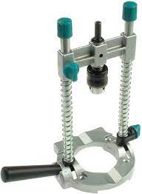 | 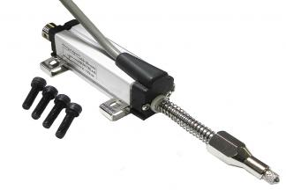 | 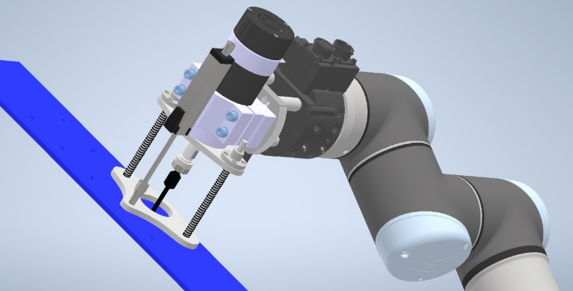
(a) | (b) | (c)
Figure 1. Deburring tool components: (a) commercial machining guide mechanism. (b) spring-loaded linear potentiometer sensor. (c) deburring tool final mechanism design.

- Counter-Sink Inspection Task (Work done by the SDP students):
  - The first successful creation of a 3D scan using the UR10 and a 2D laser profiler has been achieved, as shown in the figure below. The scan quality is poor, due to the low-rate and imprecise measurements of the robot’s end-effector position.

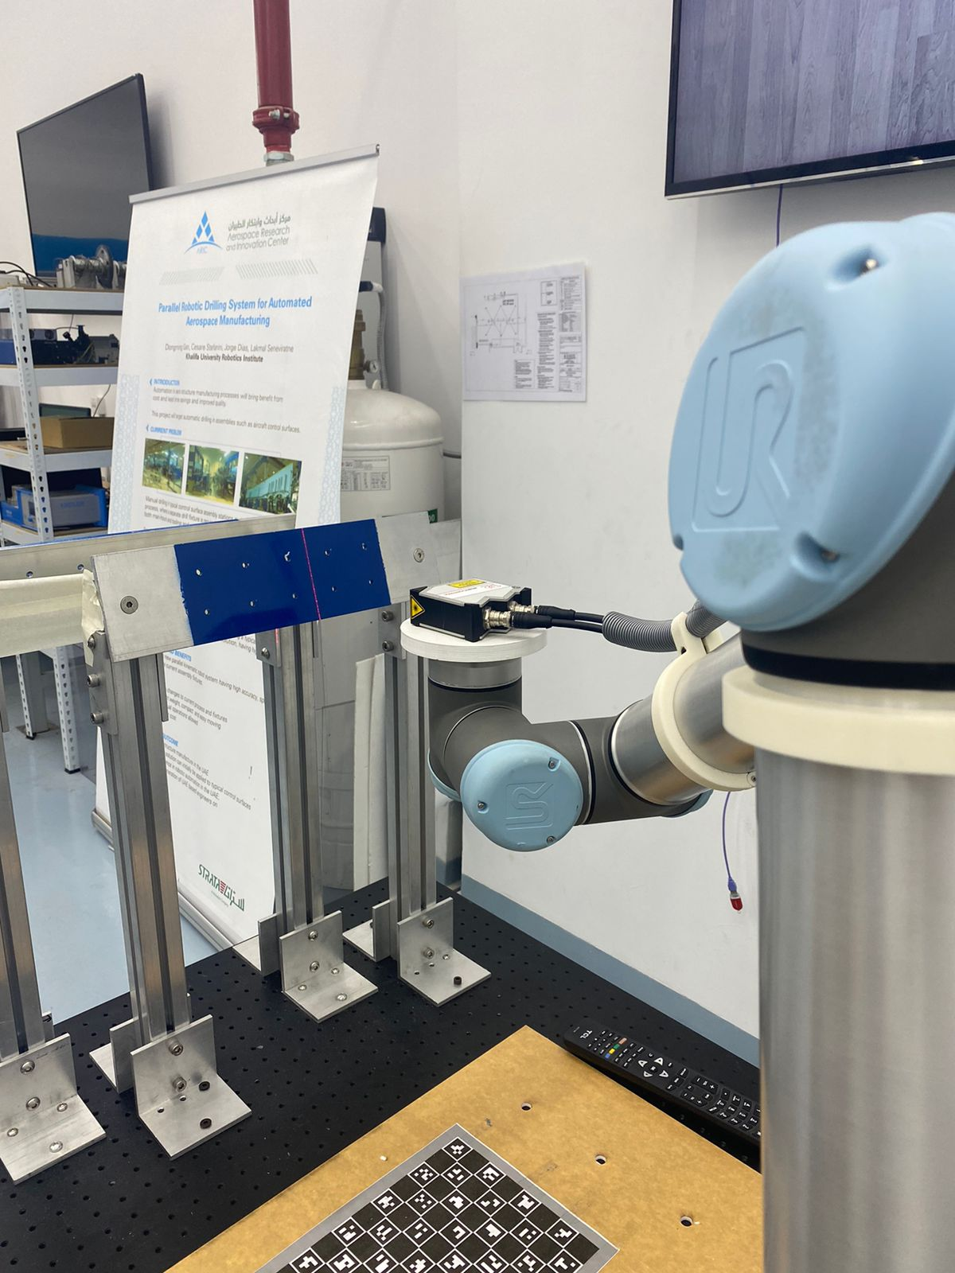 | 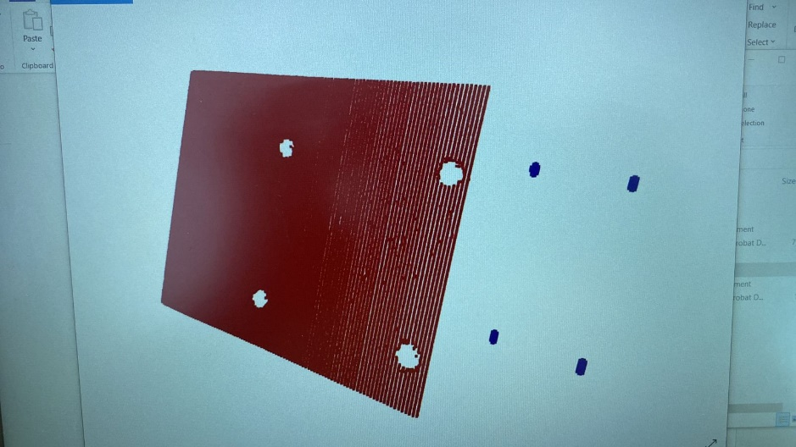
(a) | (b)

Figure 2: (a) The set-up for the robotic 3D laser scanner. (b) Initial sample results of the 3D scan.

  - To address the above issue, the SDP team have designed an end-effector with linear actuation and micro-stepping capabilities to provide more precise and faster position readings during the scanning process.
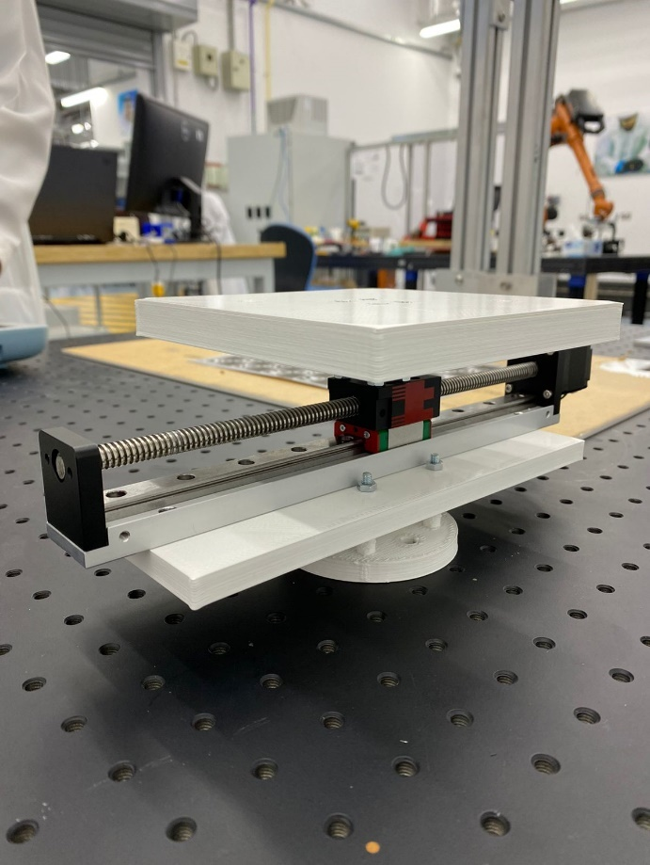
Figure 3: The 3D scanning end-effector with linear actuation and micro-stepping capabilities.

- For the vision based tactile sensor:
  - Enhanced sensor fabrication:
The silicon-based tactile sensor contained a number of flaws due to the fabrication process. These flaws included a poor material finish (high levels of porosity, due to gas being trapped in the material before molding) and bad marker arrangement in the sensor. These issues were addressed by degassing the solution in a vacuum chamber prior to curing it and with an improved marker painting scheme using a mask and spray paint.

Additionally, all of the remaining components have been 3D printed and assembled as shown below:

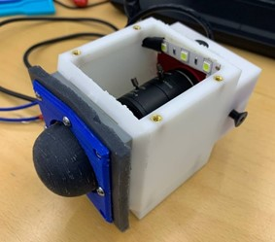 | 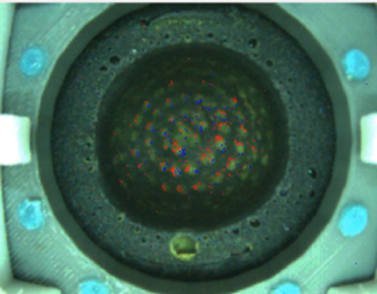
(a) | (b)
Figure 4: (a) The visuotactile sensor. (b) The feedback from the camera while the sensor is in contact with a rigid surface.

  - Tensile testing of the sensor: Prior to conducting a finite element analysis to optimize the geometry and material of the deformable interface within the sensor, we have conducted tensile tests on different materials to determine their mechanical properties. Test specimens were created according to the ASTM D412 testing standard for elastomeric testing. Tensile tests were conducted but the results are inconclusive, due to a gripping issues after a high extension of the material, involving the material slipping from the gripper jaws, Figure 5.
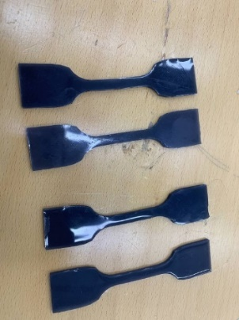 | 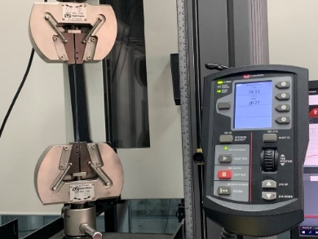
(a) | (b)
Figure 5. Tensile testing for the deformable interface of the visuotactile sensor. (a) test specimen (b) material during tensile testing.

Gantt Chart for 2022
Work Package | Month
 | 1 | 2 | 3 | 4 | 5 | 6 | 7 | 8 | 9 | 10 | 11 | 12
The modification and upgrade of the deburring end-effector.
The development of the painting end-effector
Development of the blind riveting end-effector
Counter-Sink inspection using: a) camera. b) laser profiler
Neobotix MMO-500 preparation for qualification
Vision Based Tactile Sensing for normality control
Vision Based Tactile Sensing for force/torque estimation and regulation
Vision based navigation of mobile robot
Project Closure and recommendations

Cumulative and new project outputs regarding publications and IP.
- Publication and IP updates in January:
  - No New IP during January

Lower-Limb Wearable Exoskeleton for Rehabilitation Applications

Project Objectives:
- Develop a robotic exoskeleton system to ensure the performance of standard rehabilitation procedures on patients, including; training, assistive and corrective therapy procedures.
- Incorporate advanced composite materials, which do not impose heavyweight on the user during rehabilitation.
- Compare/benchmark with the state of art exoskeleton in collaboration with Team of Scoula Superiore Santanna, Pontedera, Italy.

Updates for this month:
- Components and materials to be used in the first prototype and the majority of second prototype have been identified. Based on this information, all of the purchase requests for the DAQ, harmonic drives as well as all T-motor system components have been submitted and should be under processing. Thus, all of the procurements for the past financial year have been finalized.
- The first prototype of the knee exoskeleton is currently being produced using some components that have been ordered and actuating systems that are available in the lab (Maxon EC45) in order to investigate possible intelligent systems and control methods that can be implemented, as well as the challenges that may appear during physical experimental work. Figure 6 shows the first prototype attached to a leg.
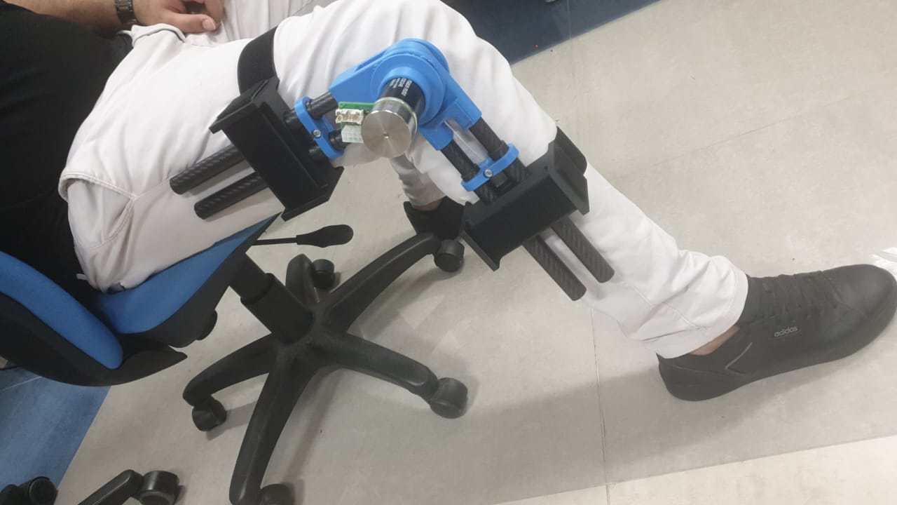
Figure 6. The first exoskeleton prototype attached to the leg.

- In terms of the actuation system that will be used in the second prototype, an active variable stiffness actuator that has been discussed in earlier reports will be employed. The Iris VSA (Figure 7) developed by the KU team will provide a suitable solution to these requirements. However, some modifications are needed:
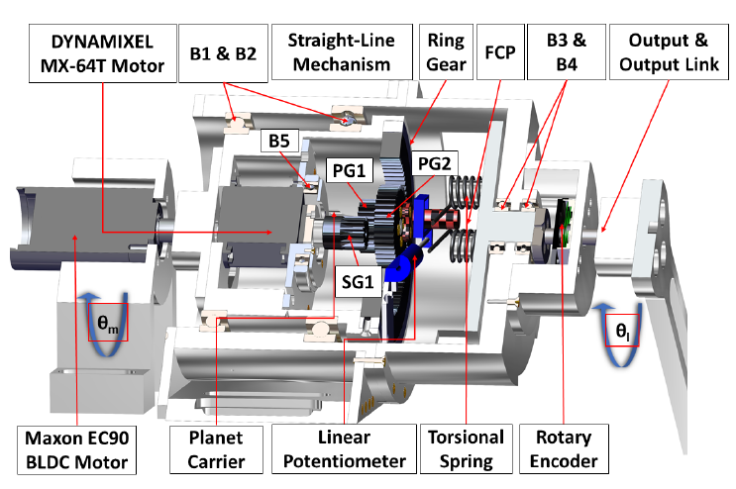
Figure 7. Concept of Iris VSA
- The Iris VSA was developed as a proof of concept model that can be used in several applications. In order to use this actuator specifically for the knee exoskeleton, the kinetics and kinematics analyses for the system, as well as force analysis for its internal gears and components, are introduced in order to study the design modifications needed.
- Based on these calculations and in order to provide a compact variable stiffness actuator in a size suitable to be used in the knee exoskeleton, modifications to the springs, gears and motors will be implemented. Thus, we have started with a new design process that will be fabricated based on our needs.

2022
2021
Work Package | Sep | Oct | Nov | Dec | Jan | Feb | Mar | Apr | May | Jun | Jul | Aug | Sep | Oct | Nov | Dec | Jan
Literature Review
Components & Material Identification
Design
Prototype Development
Procurement*
System integration
Publications and Patents
Technical Validation
Ethical approval
Clinical validation
* Procurements are completed for 2021 financial year and will be resumed once it is opened for 2022.

Manufacturing Research Activities

Good progress has been made on the projects in the manufacturing research thrust. Towards the end of 2021, a rib structure has been successfully produced for the thermoplastic project and blades have been repaired for the additive manufacturing project. Recently, a meeting has been held with Gordon Ferguson from Strata, where a number of challenges were discussed. Most importantly, the need to ensure low levels of porosity in the flanges and a good surface finish in these edges were highlighted as issues that needed to be resolved. These challenges arise from the fact that during processing, it is not possible to apply horizontal pressure to vertical flanges in the aluminum mold. During the discussion, the possibility of using a bi-material metal mold was proposed, wherein the upper and lower molds are produced from different metals (aluminum and steel, for example). This will be investigated in the coming weeks by manufacturing a simple bi-material mold and using it to compression mold parts with vertical flanges.
Discussions are planned with the Sanad-Aerotech team in order to establish the next steps in the additive manufacturing project. A number of blades have been scanned in the center’s X-CT machine and the interface between the repair and the blade appears to be good. Some tests have also been undertaken to investigate the possibility of depositing one material on a substrate based on a different material system (titanium on aluminum alloy in the present case). This approach has proved less successful, due to issues associated with the different melt temperatures of the two materials and different coefficients of thermal expansion.

Additive Manufacturing of High-performance Structures

Staffing resource: Lewis Kindleyside and Prof. Wesley Cantwell
(b)

Repair of Turbine Blades
Project Objectives:
- To investigate techniques for repairing damaged or degraded components.
- To develop fixturing techniques for the accurate placement and securing of damaged parts in the metal printer
- To identify the optimum parameters for successful repair

Progress update
The activities that were planned for 2021 have largely been completed, see the Gantt chart below. A procedure has been developed for repairing turbine blades and this has proved quite successful. Figure 8 shows a small Sanad Aerotech turbine blade that was repaired in the EOS400-4 and an X-CT image of the repaired section. An examination of the micrograph suggests that the repair has successfully fused with the substrate (turbine blade) forming a strong bond. A test specimen/technique is being designed that will enable the strength of this bond to be measured. Lewis is currently working on a simple design that will allow a blade or bladelike structure to fit in the Instron machine for subsequent tensile testing.

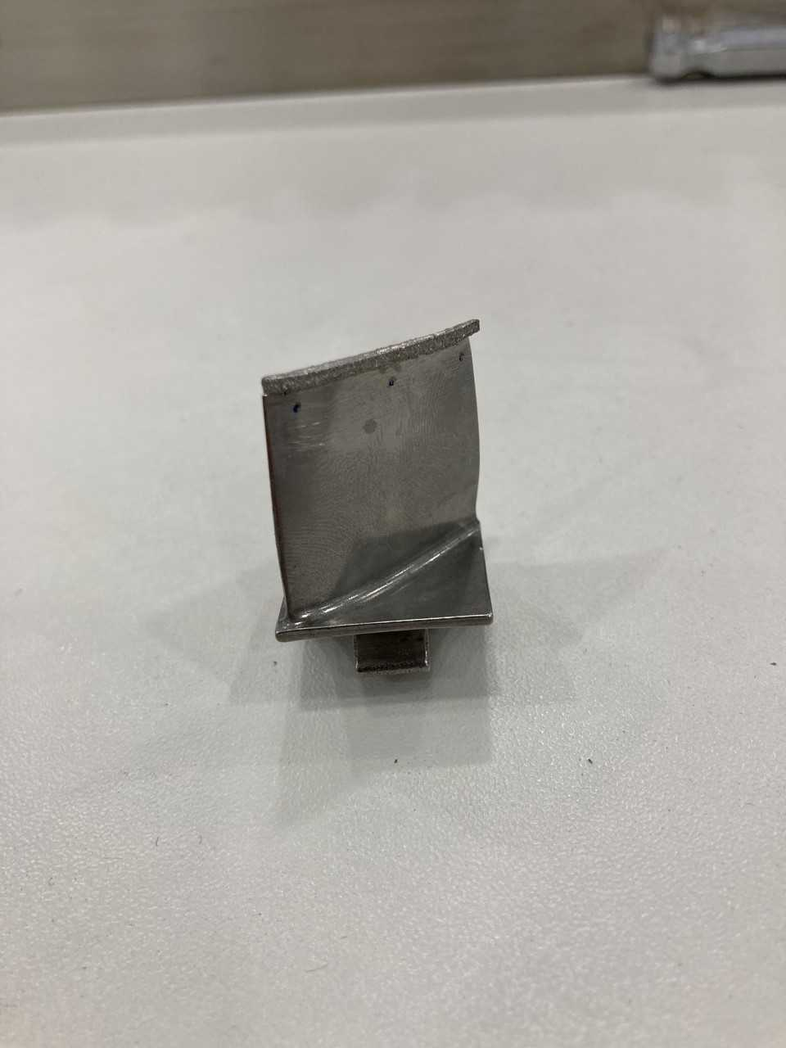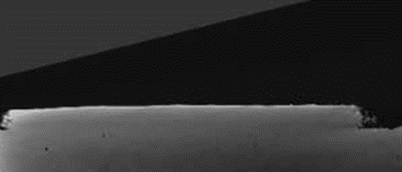
Figure 8. Photo of a repaired Sanad Aerotech blade and an X-CT micrograph showing the interface between the repair and the blade.

One of the tasks in the original program was to investigate the possibility of depositing one material type on another. In his study, titanium was deposited on an aluminum alloy substrate, as shown in Figure 9. This has proven to be a fruitless approach, since the two materials separate during the manufacturing cycle leaving a disbond at the bi-material interface. This form of failure is linked to the disparity in melting temperatures between the titanium and aluminum alloy, as well as the difference in the values of coefficient of thermal expansion of the two materials. It appears as if there is little value in exploring this approach.

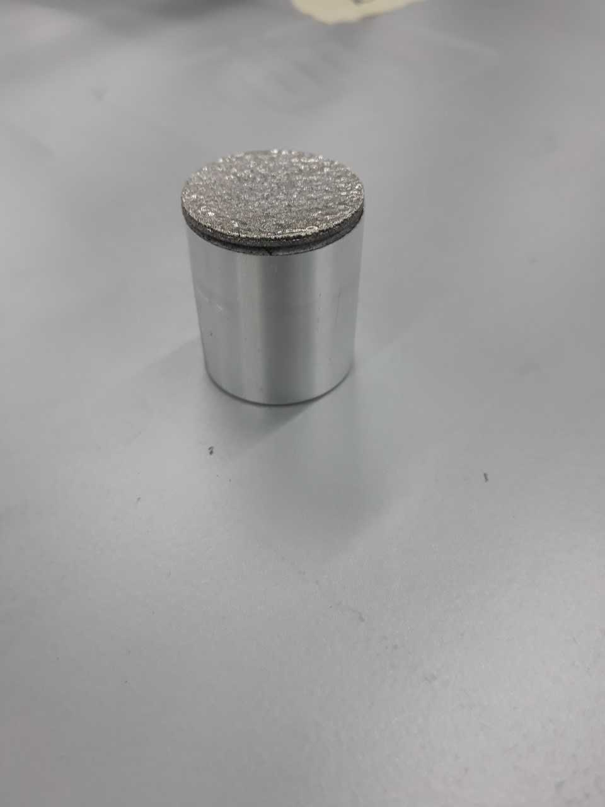
Figure 9. Titanium deposited on an aluminum substrate.

Given that the tasks associated with the initial project have largely been completed, a meeting will be arranged with the Sanad team to discuss the next steps. Brain, from Sanad Aerotech, will arrange this meeting within the next two weeks.

Gantt Chart
Work Package | Month
 | 1 | 2 | 3 | 4 | 5 | 6 | 7 | 8 | 9 | 10 | 11 | 12
Component identification
Design of experiments to highlight appropriate parameters.
Machining of the component
Fixture design
Component repair trial
Dual material manufacturing
Patent disclosure

Manufacturing of B-777/787 Ribs Using Thermoplastic Composites

Staffing resource: M. Alkrunz, Satish Verenkar and Wesley Cantwell
(b)

Project Objectives:
- Develop capabilities to manufacture thermoplastic aircraft ribs
- Develop research capabilities to address and mitigate manufacturing associated issues
- Contribute to the process of Emiratization

Progress
The thermoplastics team has now successfully manufactured a number of carbon fiber/polyetherketoneketone (PEKK) ribs. During January, an additional rib has been manufactured and sectioned for examination in the center’s X-ray computed tomography (X-CT) machine. Figure 10 shows a CF/PEKK rib along with a schematic showing the locations from where sections were removed.
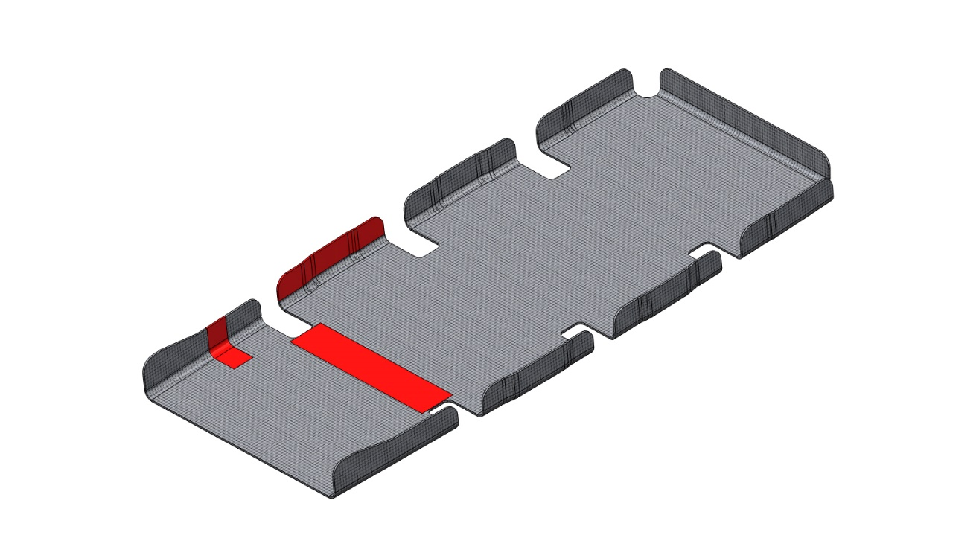
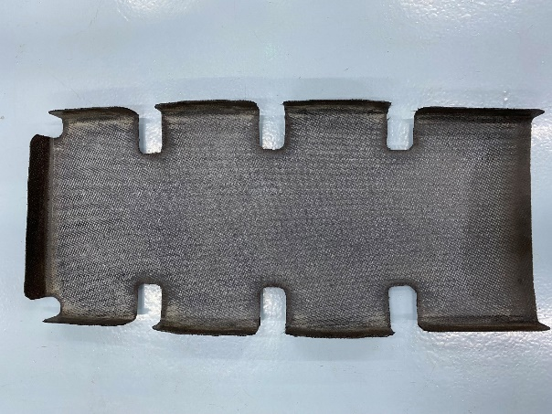
T2
T3
T1

Figure 10. Carbon fiber/PEKK rib and schematic showing the loations of samples for examination in the X-CT machine.

The resuting X-CT micrographs are shown in Figure 11, where images of two of the three sections removed from the rib are shown. The view of the central section, taken from above the plane, indicates a high level of consolitation. The X-CT views of the flanges suggest some localized porosity, as well as some surface uneveness. These defects are linked to the fact that no lateral pressure is applied to these flanges during consolidation. Clearly, the downward pressure on the main body of the rib is sufficient to ensure good levels of consolidation. In contrast, it is very difficult to apply a horizontal pressure to the flanges, this results in low-level voiding and a diminished surface quality.

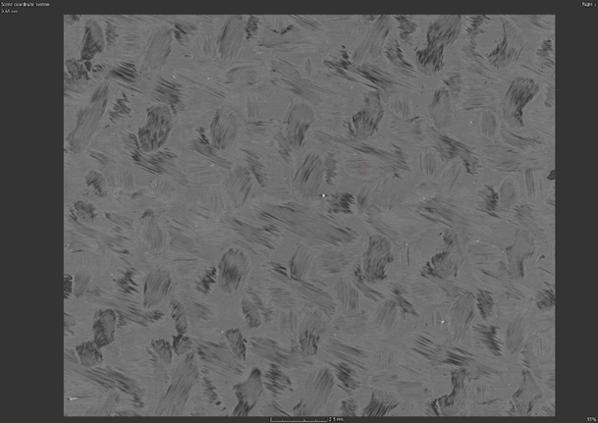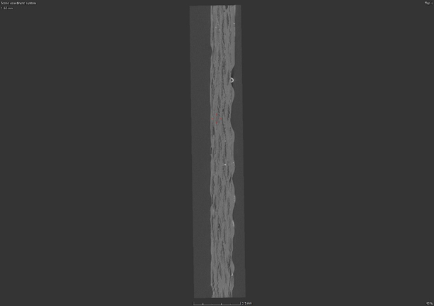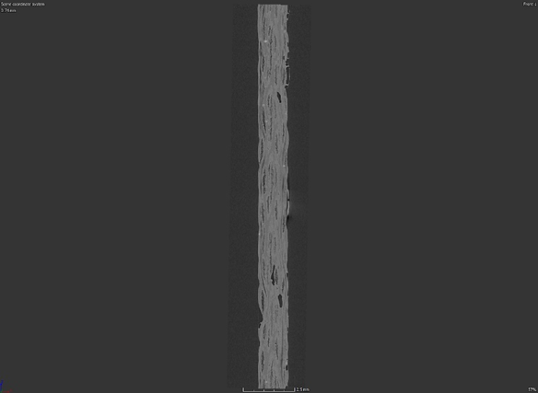
- (b) (c)

Figure 11. X-CT images of a CF/PEKK rib: (a) T2 from above (b) T1 looking down on the top edge (C) T1 looking horizonatlly at the side edge.

Progress on the project and the next steps were discussed during an online meeting involving Gordon Ferguson (Strata) and WJC on the 2nd of February 2022. Mohammed AlKrunz and Satish Verenkar were also in attendance. The issue of posority and increased surface rugosity in the flanges was discussed and Gordon suggested using a bi-material mold, where the upper half is made from aluminum and the lower from steel. The difference in coefficient of thermal expansions between the two materials will generate an increased pressure as the mold is heated, resulting in greater consolidation within the composite. Following this discussion, a simple bi-material mold has been designed and this will be fabricated in the workshop, Figure 12. The mold is a proof-of-concept design that will be used to demonstrate that this bi-material approach can be use to fully-consolidate complex parts. During the meeting with Gordan, it was agreed that Satish and Mohammed would visit Strata in the coming days in order to understand the company’s needs. They will take one of the ribs with them.
The activity falls under ‘rib forming’ in the Gantt chart shown below.

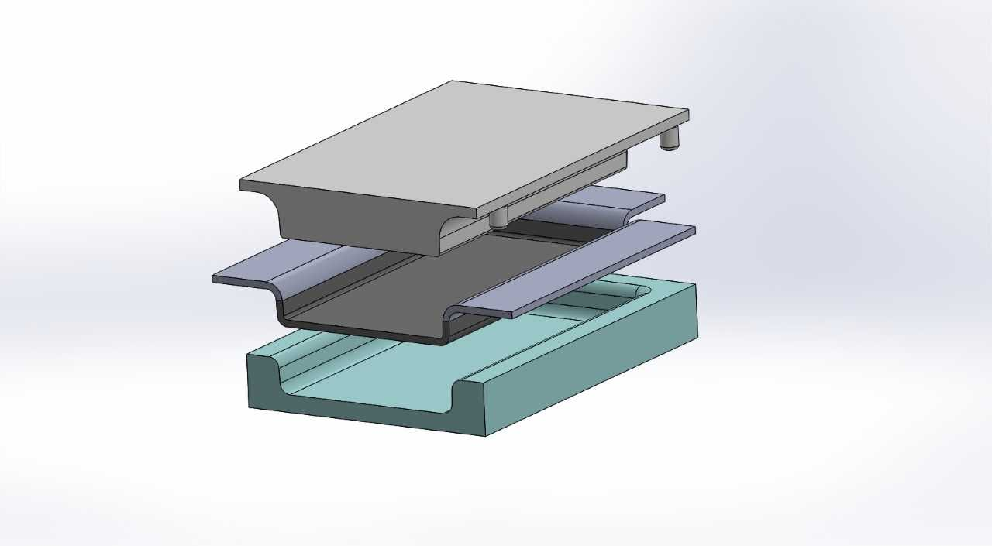
Figure 12. Schematic of the bi-material mold that has been proposed following discussions with Strata.

Gantt Chart for Thermoplastic Rib Project
Tasks & Activities |  | Period 1 | Period 2 |  | Period 3 |  | Period 4
 |  | Q4 | Q1/Q2 | Q3/Q4 | Q1/Q2 | Q3/Q4 | Q1/ Q2 | Q3
 |  | 2019 | 2020 |  | 2021 |  | 2022
WP 1: Material selection
1 | Material selection
2 | Structural requirements
3 | Coupon testing
4 | Allowables
WP 2: Process simulation
1 | Model generation
2 | Single curvature tests
WP 3: Tooling
1 | Design
2 | Material selection
3 | Simulation
4 | Prototype
5 | Final tool
WP 4: Bonding
1 | Thermoplastic welding
2 | Resistance welding
3 | Co-consolidation
WP 5: Prototype
1 | Rib forming
2 | Iso-grids
3 | Testing

Progress towards KPIs

KPI #3. Four SDP students are currently working on a senior design project related to the testing of composites: Mohamed Alameri, Aysha Alketbi, Ahmed Altamimi and Hamad Albloshi.

2022 KPI’s: New KPIs/targets are needed

#1 Number of Q1 papers published through ARIC’s team: (Target: 1 per USD $50k invested in research) – 0 papers published in 2022

#2 Number of problems being solved for industry (Target: 3)
Thermoplastic aircraft rib
Repair of turbine blades
Drilling of aerospace structures

#3 Number of UAE nationals deployed on ARIC’s projects (Target: 6 including undergraduate activities) - 8 students currently on SDP projects.

#4 Number of patents filed (Target: 4 disclosures filed) 0 patents filed in 2022

#5 Number of articles in local/international media highlighting ARIC’s role/achievements (Target: 3) 0 prepared in 2022.

Budget Summary
The ARIC contract will end on the 30th of November 2022. We are therefore 10% of the way through the year and we have spent 4% of the budget for this year.

